Macro 1 Unit Progress Check – From AP Website

Question 1
Allie is shopping when she finds a pair of running shoes priced at $90. When Allie uses her debit card to pay, it is declined because her balance is insufficient to cover the cost of the running shoes Allie's situation best illustrates which economic concept?
- Opportunity cost
- Scarcity
- Unlimited resources
- Trade-offs
- Trade

Question 2
Which of the following is not a scarce resource?
- Land
- Labor
- Capital
- Entrepreneurship
- Stocks

Question 3
Which of the following contributes to the economic problem of scarcity?
- Human wants are insufficient
- Resources are unlimited
- Resources are efficient.
- Resources are expensive
- Resources have alternative uses so we must make choices.

Question 4
Which of the following illustrates the effect of a decrease in an economy's resources using a production possibilities curve (PPC)?
- The economy's PPC will shift inward ie. to the left
- The economy's PPC will shift outward ie. to the right
- The economy's PPC will become steeper
- The economy's PP will become flatter.
- The economy's PPC will remain the same United States.

Question 5
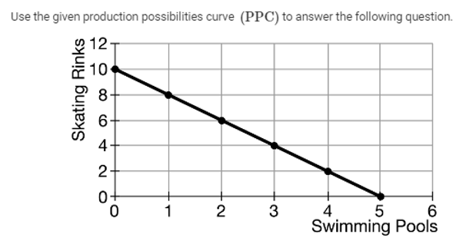
A city government received a $1 million grant to build swimming pools and skating rinks for youth. Based on the data provided in the graph, what is the opportunity cost of building one swimming pool?
- 0.50 skating rink
- 0.50 swimming pool
- 2 skating rinks
- 2 swimming pools
- 5 skating rinks

Question 6
Use the graphs to answer the question below.
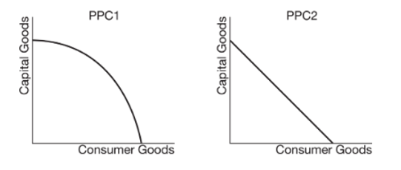Capital
The shape of a PPC illustrates the type of opportunity costs involved in production. What type of costs do PPC1 and PPC2 illustrate?
- PPC1 illustrates constant opportunity costs and PPC2 illustrates increasing opportunity costs.
- PPC1 illustrates constant opportunity costs and PPC2 illustrates decreasing opportunity costs.
- PPC1 illustrates increasing opportunity costs and PPC2 illustrates decreasing opportunity costs.
- PPC1 illustrates increasing opportunity costs and PPC2 illustrates constant opportunity costs.
- PPC1 illustrates decreasing opportunity costs and PPC2 illustrates constant opportunity costs.

Question 7
Use the table to answer the question below.
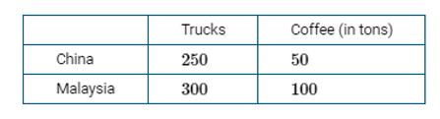
The table above shows the daily production possibilities for China and Malaysia in producing trucks and coffee using the same amount of resources Based on the data provided, which of the following terms of trade are mutually beneficial for the two countries?
- 1 ton of coffee for 3 trucks
- 1 ton of coffee for 4 trucks
- 1 ton of coffee for 5 trucks
- 1 truck for 1 ton of coffee
- 1 truck for 5 tons of coffee

Question 8
Michael and Martha run a mechanic shop. In one hour Michael can perform eight oil changes or change ten tires. In one hour Martha can perform seven oil changes or change fourteen tires. Given this information which of the following is true?
- Martha has a comparative advantage in changing oil.
- Martha has an absolute advantage in changing oil
- Michael has a comparative advantage in changing tires.
- Michael has an absolute advantage in changing tires.
- Michael has an absolute and a comparative advantage in changing oil

Question 9
The table below shows the landscaping productivity of Simone and Irina during an eight hour workday. Simone can mow twelve lawns or trim twenty four trees in eight hours. Irina can mow nine lawns or trim twelve trees in eight hours.
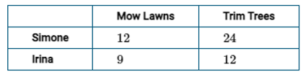
Based on the information in the table, which of the following is true?
- Irina has an absolute advantage in mowing lawns.
- Irina has an absolute advantage in trimming trees.
- Irina has a comparative advantage in trimming trees.
- Simone has an absolute advantage in trimming trees and mowing lawns.
- Simone has a comparative advantage in trimming trees and mowing lawns.

Question 10
Which of the following describes the relationship between price and quantity demanded according to the law of demand?
- Positive relationship, illustrated by an upward-sloping demand curve
- Positive relationship, illustrated by a downward-sloping demand curve
- Negative relationship, illustrated by a horizontal demand curve
- Negative relationship, illustrated by an upward-sloping demand curve
- Negative relationship, illustrated by a downward-sloping demand curve

Question 11
Country X is a major buyer of Country Y's grains. Assume Country X's government announced an increase in taxes on its imports of Country Y's grains effective next month. How will this news likely affect consumers' demand for grains in Country X?
- It will increase now because the tax on imported grains will increase the future price of grains.
- It will decrease now because the tax on imported grains will increase the future price of grains.
- It will not change now because the tax on imported grains will increase the future price of grains.
- It will increase now because the tax on imported grains will increase the current price of grains,
- It will decrease now because the tax on imported grains will increase the current price of grains.

Question 12
Which of the following changes will increase the demand for bicycles?
- An increase in the price of bicycle helmets, a complementary good
- An increase in the price of scooters, a substitute good
- A decrease in the price of bicycles
- A decrease in consumers' income
- A decrease in the number of buyers

Question 13
Which of the following describes the relationship between price and quantity supplied according to the law of supply?
- Positive relationship, illustrated by an upward-sloping supply curve
- Positive relationship, illustrated by a downward-sloping supply curve
- Positive relationship, illustrated by a horizontal supply curve
- Negative relationship, illustrated by an upward-sloping supply curve
- Negative relationship, illustrated by a downward-sloping supply curve

Question 14
Which of the following will increase the market supply for new automobiles?
- An increase in the price of steel, an input in the production of automobiles
- An increase in taxes on automobile manufacturers
- An increase in subsidies to automobile manufacturers
- An increase in consumers income
- An increase in the price of gasoline, a complementary good

Question 15
Two nations sign a trade agreement expecting to enjoy mutual gains from the trade of a certain good. How will this event likely affect the supply of the good in the two nations?
- This event will likely cause a decrease in the quantity supplied of the good in both nations
- This event will likely cause an increase in the quantity supplied of the good in both nations.
- This event will likely cause a decrease in the supply of the good in both nations.
- This event will likely cause an increase in the supply of the good in both nations
- This event will likely have no effect on the good in either nation.

Question 16
Use the table to answer the question below.
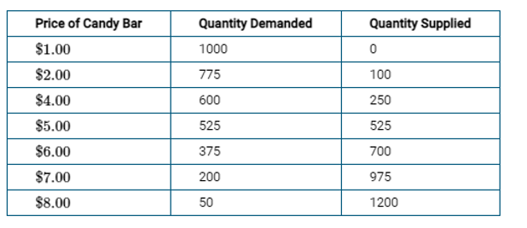When the price of a candy bar is $6.00, which of the following is true?
- The market does not clear because the price is lower than the equilibrium price and there will be a surplus in the market.
- The market does not clear because the price is lower than the equilibrium price and there will be a shortage in the market.
- The market clears because buyers and sellers are in agreement on the price
- The market does not clear because the price is higher than the equilibrium price and there will be a surplus in the market.
- The market does not clear because the price is higher than the equilibrium price and there will be a shortage in the market.

Question 17
Use the graph to answer the question below.
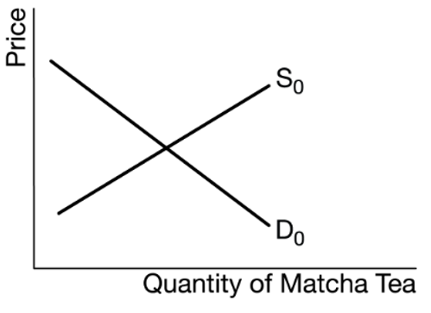
Matcha green tea is primarily cultivated by Japanese farmers. Suppose that Matcha green tea grows in popularity as its health benefits, namely its lower caffeine content, become known, and at the same time the government reduces taxes imposed on Japanese tea farmers What is the likely effect on the equilibrium price and quantity in the Japanese Matcha tea market?
- Price increases, and quantity increases.
- Price decreases, and quantity decreases.
- Price is indeterminate, and quantity increases
- Price is indeterminate, and quantity decreases
- Price decreases, and quantity is indeterminate

Question 18
Assume household income has fallen dramatically in Country X and the cost of construction materials for building new houses has increased. How will these changes affect the equilibrium price and equilibrium quantity for new houses?
- The equilibrium price will increase, and the equilibrium quantity will decrease.
- The equilibrium price will decrease, and the equilibrium quantity will decrease.
- The equilibrium price will decrease, and the equilibrium quantity will increase
- The equilibrium price will decrease, and the equilibrium quantity will be indeterminate.
- The equilibrium price will be indeterminate, and the equilibrium quantity will decrease

Answers
1 | B | 11 | A
2 | E | 12 | B
3 | E | 13 | A
4 | A | 14 | C
5 | C | 15 | D
6 | D | 16 | D
7 | B | 17 | C
8 | E | 18 | E
9 | D
10 | E

